Charts and Visualizations EDA
- Store performance: Weekly Sales distribution
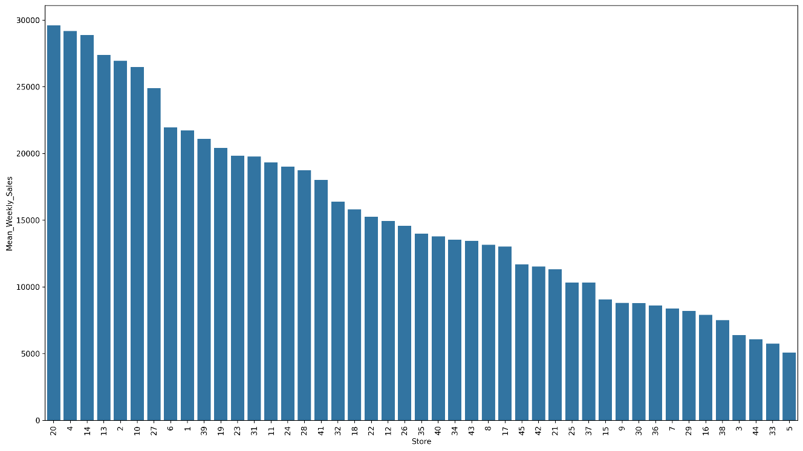
Observation: Store 20 generated the highest total sales while Store 5 generated the lowest. Sales performance differs substantially across stores, suggesting that store-specific factors influence demand
- Department Analysis:
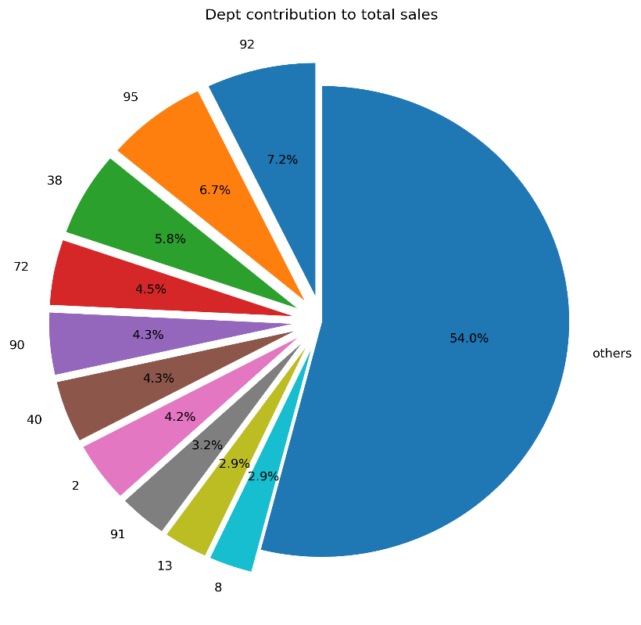

- Store Type Performance
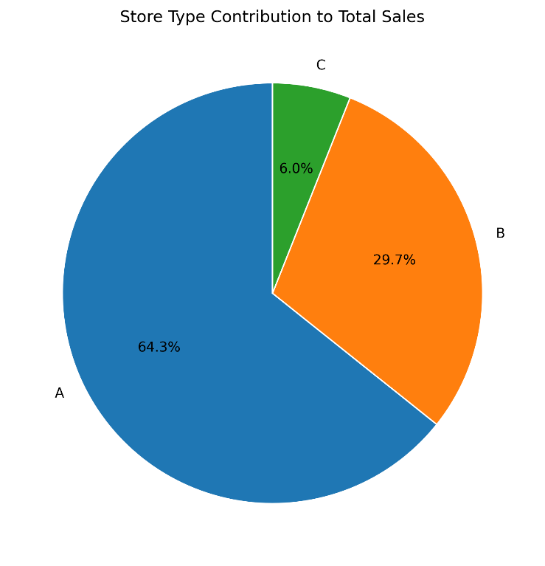
- Store Size Performance
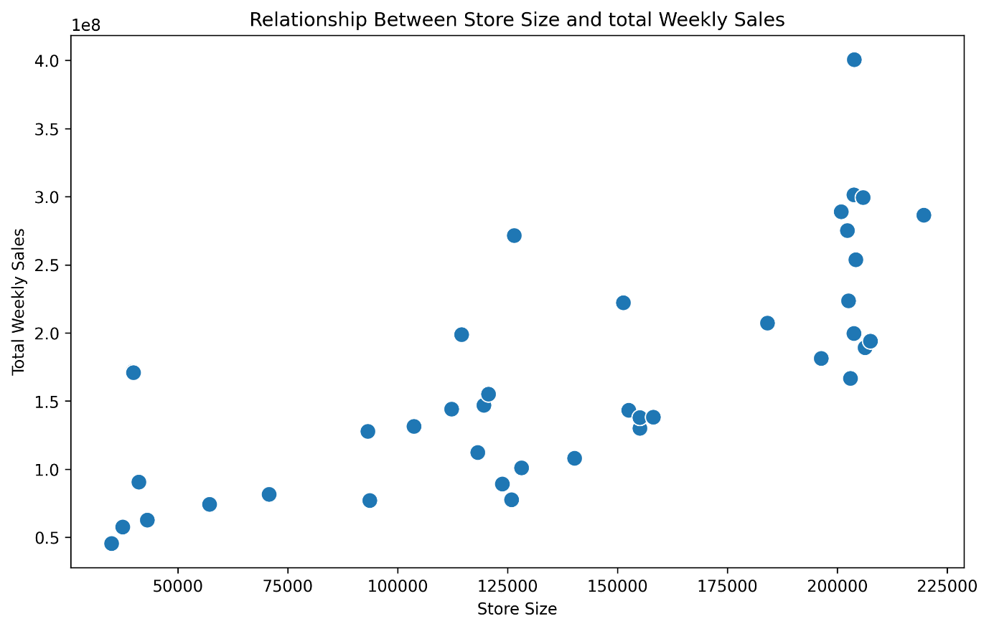
There is a positive relationship between store size and weekly sales. Larger stores generally generate higher weekly sales. But we cannot conclude that size alone determines sales. Stores around 200,000 sq.feet have sales ranging from 170 to 400 million. Other factors such as location, storetype, promotions, holidays, unemployement, CPI and fuel prices could also possibly affect.
- Time based performance
Weekly:
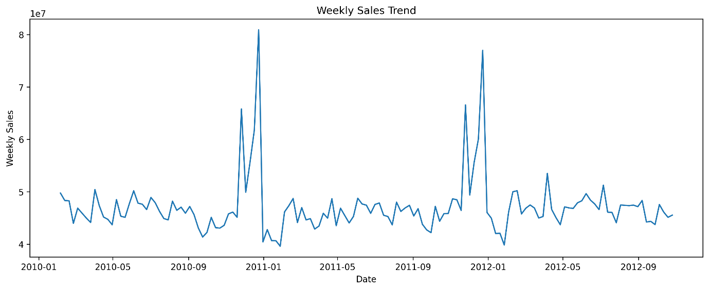
The graph shows sharp peaks around the weeks in November- December 2010 and Nov- December 2012. These are festivity seasons of thanksgiving and Christmas.
Monthly:
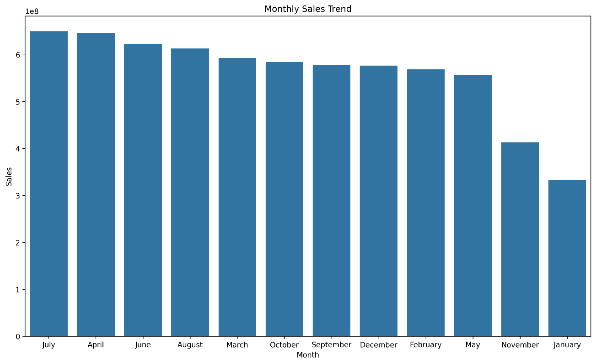
The month of July shows the highest overall sales.

Quarterly:
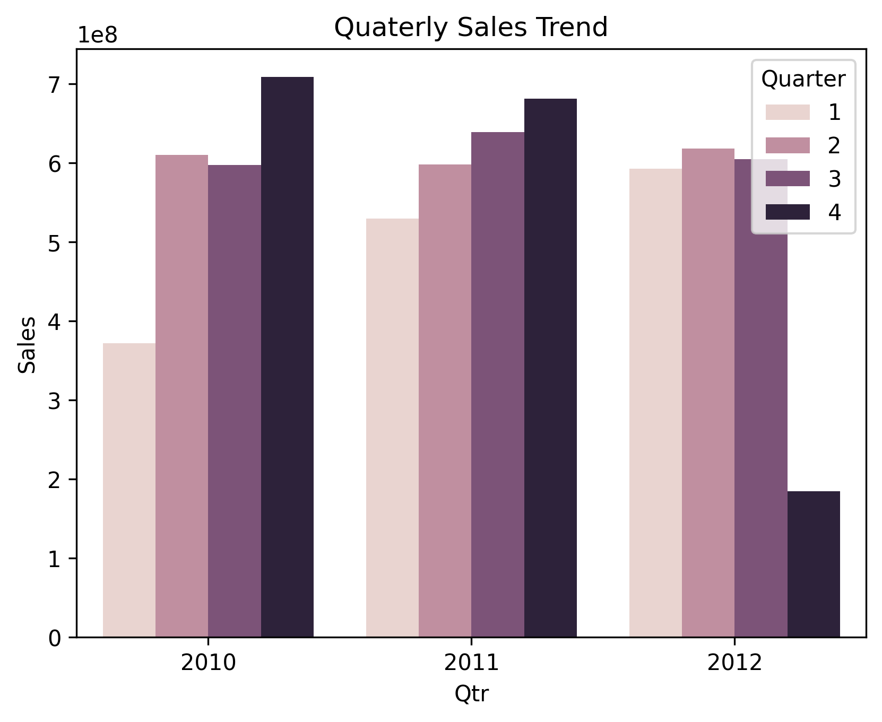
Yearly:
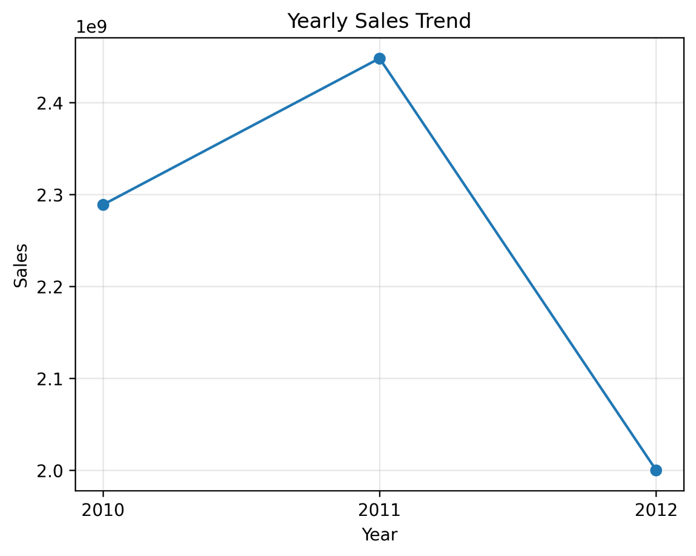
- Holiday analysis
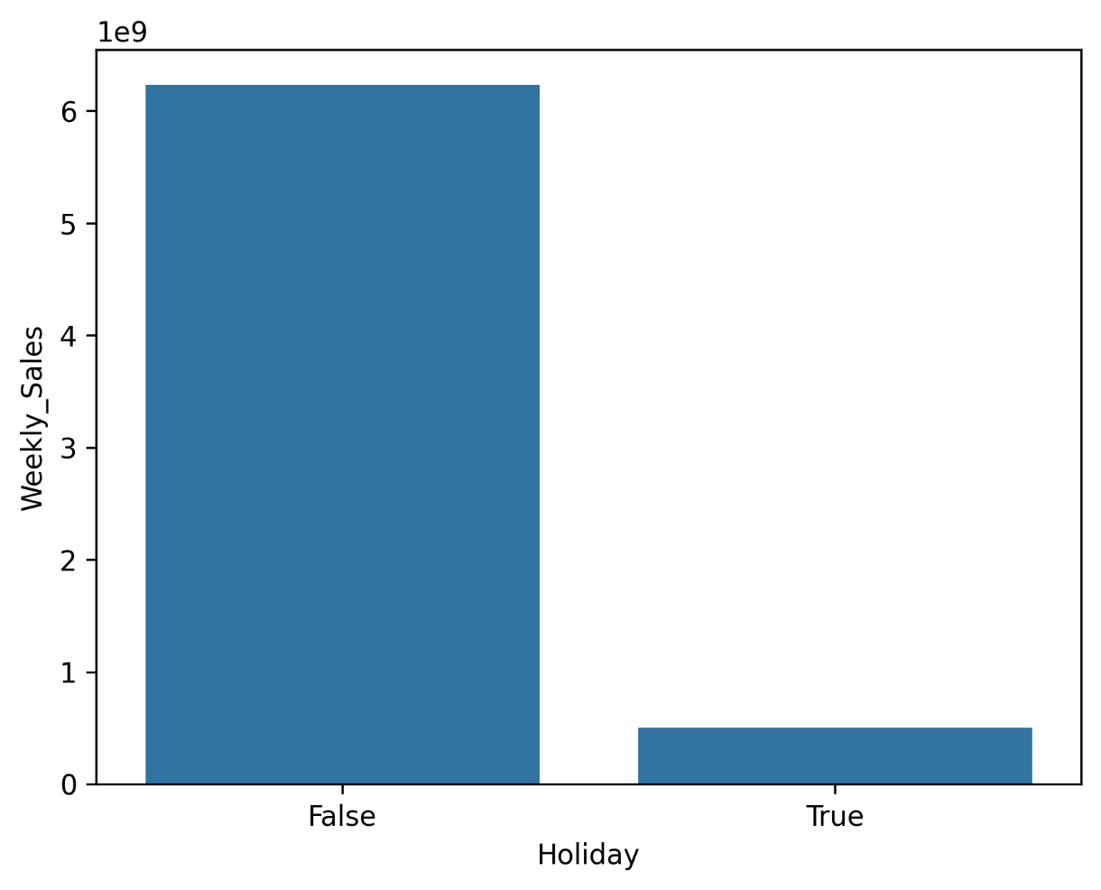
- Promotion performance
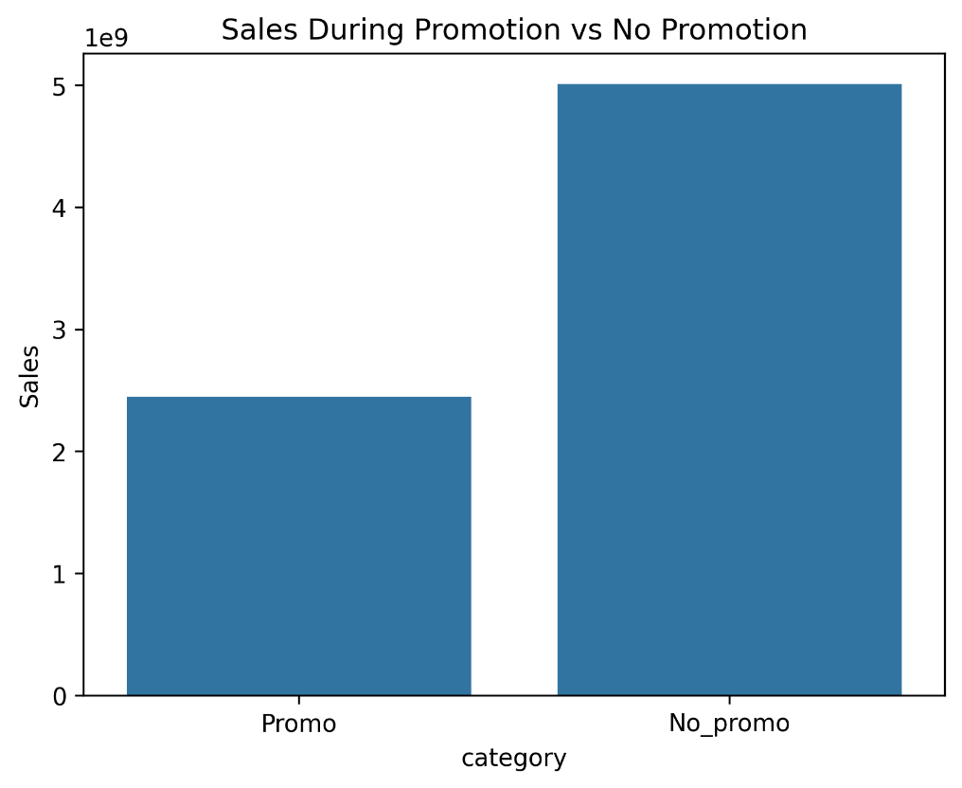

Business Insights
Store Performance:
- Store 20 shows the highest mean sales
Top 5 stores as per weekly mean sales
Store | Mean_Weekly_Sales
20 | 29,619
4 | 29,176
14 | 28,877
13 | 27,394
2 | 26,956

- Store 5 shows the lowest mean sales
Bottom 5 stores as per weekly mean sales
Store | Weekly_Sales
5 | 5,065.00
33 | 5,736.00
44 | 6,061.00
3 | 6,380.00
38 | 7,502.00

- Standard deviation is the highest in store 14, meaning this store shows highest variation in sales.
Top 5 stores showing high SD
Store | SD_Weekly_Sales
14 | 36,934
20 | 35,682
4 | 34,586
13 | 33,862
2 | 33,089

- Coefficient of Variance is highest in Store 23 meaning this store is the most stable.
Top 5 stores showing high CV
Store | CV
23 | 1.05
11 | 1.06
6 | 1.08
8 | 1.15
21 | 1.15

Department Performance:
- Store 92 is the top selling dept selling 75,204 between 2010-2012
- Store 43 is the least selling dept selling 1.2 between 2010-2012
- Store 92 has the maximum contribution of 7.18% to total sales
Store type Analysis
- There are 3 types of stores, 22 stores in type A, 17 stores in type B, 6 stores in type C. Where 64 percent is contributed by type A
Store Size Performance
- The correlation coefficient between store size and weekly sales is 0.72. Hence there is a positive linear relationship between the 2 variables.
Time based performance
- Weekly performance(Top 5)
Date | Store | Weekly_Sales
24/12/2010 | 14 | 3,818,686.45
24/12/2010 | 20 | 3,766,687.43
24/12/2010 | 10 | 3,749,057.69
23/12/2011 | 4 | 3,676,388.98
24/12/2010 | 13 | 3,595,903.20

- Monthly- July recorded the highest cumulative sales across
Month | Year | Store | Weekly_Sales
1 | 2011 | 4 | 7,428,613.52
1 | 2012 | 4 | 7,923,348.95
2 | 2010 | 14 | 8,627,837.12
2 | 2011 | 20 | 8,759,767.97
2 | 2012 | 4 | 9,202,336.89
3 | 2010 | 14 | 8,510,254.38
3 | 2011 | 4 | 8,203,913.86
3 | 2012 | 4 | 10,804,712.46
4 | 2010 | 14 | 11,096,719.43
4 | 2011 | 20 | 10,208,135.78
4 | 2012 | 4 | 8,784,208.07
5 | 2010 | 14 | 8,835,228.31
5 | 2011 | 14 | 8,140,792.27
5 | 2012 | 4 | 8,685,981.98
6 | 2010 | 14 | 9,108,087.01
6 | 2011 | 14 | 8,363,967.27
6 | 2012 | 4 | 10,984,472.54
7 | 2010 | 14 | 10,800,319.99
7 | 2011 | 4 | 10,193,027.80
7 | 2012 | 4 | 8,548,929.23
8 | 2010 | 14 | 8,350,268.69
8 | 2011 | 4 | 8,487,108.44
8 | 2012 | 4 | 10,857,845.15
9 | 2010 | 14 | 8,208,260.40
9 | 2011 | 4 | 10,208,060.69
9 | 2012 | 4 | 8,390,018.08
10 | 2010 | 14 | 9,800,918.92
10 | 2011 | 4 | 8,600,688.22
10 | 2012 | 4 | 8,589,722.81
11 | 2010 | 20 | 9,288,774.87
11 | 2011 | 4 | 9,732,895.19
12 | 2010 | 20 | 13,554,389.64
12 | 2011 | 20 | 13,207,144.74

- Quarterly performance- Top stores- quarter wise- year wise
Quarter | Year | Store | Weekly_Sales
1 | 2010 | 14 | 17,138,091.50
1 | 2011 | 4 | 24,334,050.96
1 | 2012 | 4 | 27,930,398.30
2 | 2010 | 14 | 29,040,034.75
2 | 2011 | 14 | 26,573,708.86
2 | 2012 | 4 | 28,454,662.59
3 | 2010 | 14 | 27,358,849.08
3 | 2011 | 4 | 28,888,196.93
3 | 2012 | 4 | 27,796,792.46
4 | 2010 | 20 | 32,573,720.65
4 | 2011 | 4 | 31,478,429.92
4 | 2012 | 4 | 8,589,722.81

- Yearly top 5 performers
Year | Store | Weekly_Sales
2010 | 14 | 105,462,946.28
2010 | 20 | 101,734,374.38
2010 | 4 | 95,681,368.81
2010 | 2 | 95,282,090.33
2010 | 13 | 95,272,832.85
2011 | 4 | 111,092,324.33
2011 | 20 | 109,838,734.90
2011 | 14 | 106,097,165.65
2011 | 13 | 104,537,549.41
2011 | 10 | 98,919,234.32
2012 | 4 | 92,771,576.16
2012 | 20 | 89,828,272.17
2012 | 13 | 86,707,568.10
2012 | 2 | 81,496,794.25
2012 | 10 | 78,230,422.46

Holiday Analysis:
- Holiday sales
holiday_sales_storewise:
Store | Weekly_Sales
20 | 22,491,780.85
4 | 22,431,026.24
14 | 21,205,829.98
10 | 21,138,063.24
13 | 21,130,438.06

Holiday_sales_department_wise:
Dept | Weekly_Sales
72 | 40,314,400.37
92 | 35,695,397.10
95 | 29,996,233.40
38 | 25,682,245.57
90 | 21,209,128.22

Average holiday sales is: 17,092.57
- Non holiday sales
Average holiday sales is: 15,949.96
Non_holiday_top5_stores:
Store | Weekly_Sales
20 | 278,909,600.60
4 | 277,114,243.06
14 | 267,796,034.46
13 | 265,387,512.30
2 | 254,594,239.50

Non_Holiday_deptwise:
Dept | Weekly_Sales
92 | 448,247,944.77
95 | 419,323,929.12
38 | 367,435,891.35
90 | 269,859,335.46
40 | 268,944,913.47

Promotion analysis
During promotion total sales: 2449746112.91= 2.5M
During non_promotional weeks total sales: 5008354489.79= 5M
Around 36% of total sales happened during promotional weeks
- Correlation between the markdowns with weekly sales
The correlation analysis shows that all MarkDown variables have a very weak positive relationship with Weekly Sales (r = 0.02–0.05). MarkDown1 and MarkDown5 show the highest correlation (r = 0.05), but the relationship is negligible. This suggests that promotional discounts alone are not drivers of weekly sales, and other factors such as store size, location, department, holidays, and seasonality are likely to have a greater influence on sales performance.
External Factors
Correlation between weekly sales and external factors
Weekly_Sales 1.00
Fuel_Price 0.00
Temperature -0.00
CPI -0.02
Unemployment -0.03

These external factors have little to no linear relationship with weekly sales. Therefore, fluctuations in these macroeconomic factors appear to have minimal direct impact on Walmart's weekly sales compared with business-specific factors such as store size, holidays, promotions, and store characteristics.

Executive Summary
- Store 20 was the highest-performing store.
- Department 92 contributed the largest share of sales.
- Type A stores generated 64% of total revenue.
- Store size showed a strong positive relationship with sales (r = 0.72).
- Holidays increased average weekly sales.
- Promotions and external economic variables showed weak linear relationships with sales.

